Vinegar Food Restaurant

*User Guide*

|  |  |  |
| --- | --- | --- |
| **Supervisor.** | **Sir HASSAN NADEEM** | |
| **Batch.** | **2206C1** | |
| **Group.** | B | |
| **Serial No.** | **Enrollment Number** | **Student Name** |
| 1. | 123456 | JAMILA MUGHAL |
| 2. | 123456 | MARYAM NADEEM |
| 3. | 123456 | MUHAMMAD SUMMAID SIDDIQUI |
| 4. | 123456 | SHEHREYAR KHAN KUNDI |



1. **Home** (*index (1).html*)

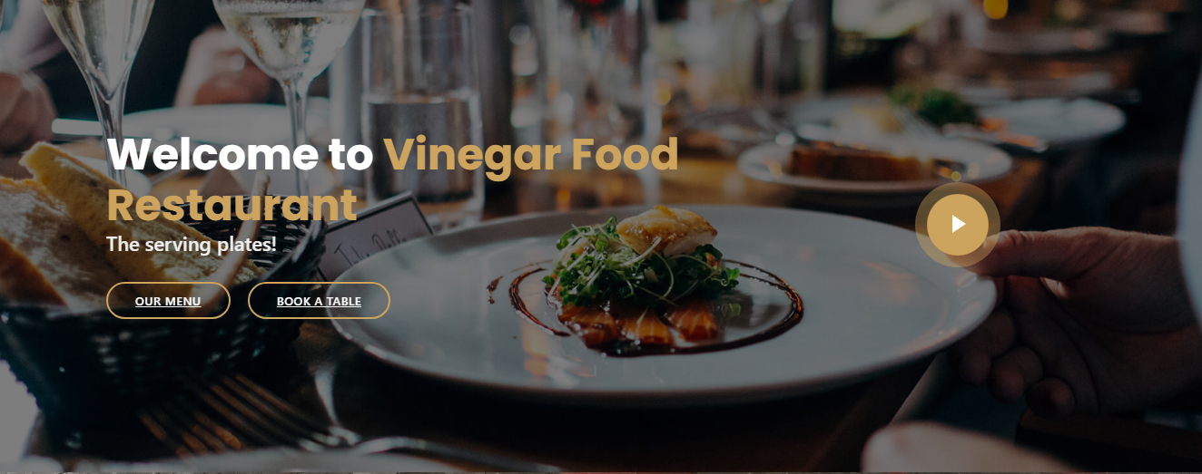

***Figure 1: Home page to VINEGAR FOOD RESTAURANT***

 Our Slogan has given to the peoples toward our website. “The Serving plates!”.

* By clicking (**Our menu**) button user while redirect to the main webpage.
* By clicking (**Book a Table**) button user while redirect to the main webpage.

1. **Navbar (index (1).html)**



***Figure 2: Navbar***

We have given nine essentials. By clicking any of the essential’s and redirect to the linked page. (0. Index (1).html)

1. **About us (index (1).html)**

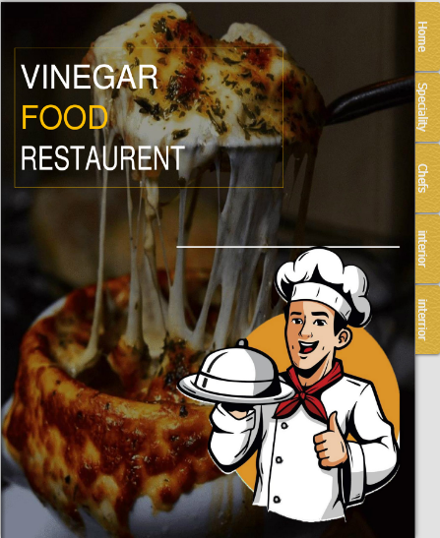

***Figure 3: About us***

**



** Explore different habitats, from the sweltering tropics to tidal rock pools.

** Discover all about our weird and wonderful creatures with fun and interactive learning experience.

**To be a destination of choice where all are welcome and motivated to join as a driving force for aquatic life.

**4.Service (index (1).html)**

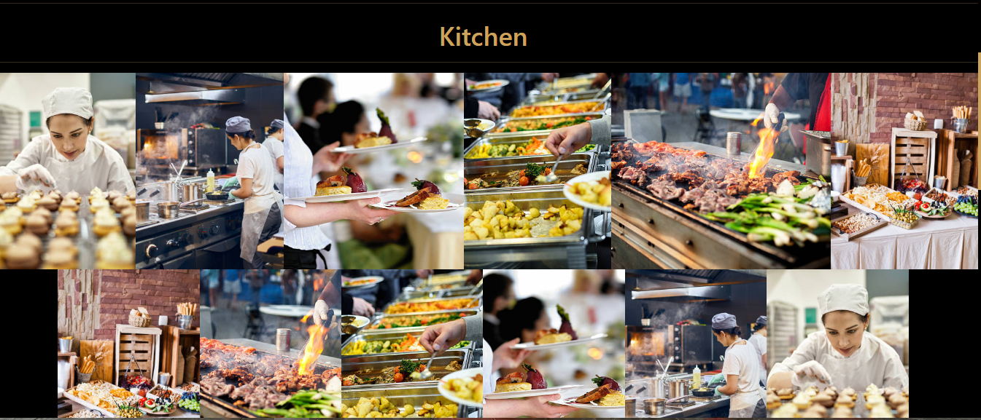

***Figure 4: Service***

*We have mentioned our basic services to make people known about the service we provide.*

** ***Home based food:*** *On our first service we have mentioned about providing home-based food and providing them good environment.*

* ***Delicious food:*** *We are giving idea about providing foodie environment at home and we have mentioned how can be treat member at home.*
* ***Cleaning Service:*** *We have mentioned that we are providing food home cleaning services to the customer.*
* ***Customer Service:*** *For the ease of the people our website is providing customer service for the customer so that they can contact directly to our restaurant assistant*

***6.Menu bar:***

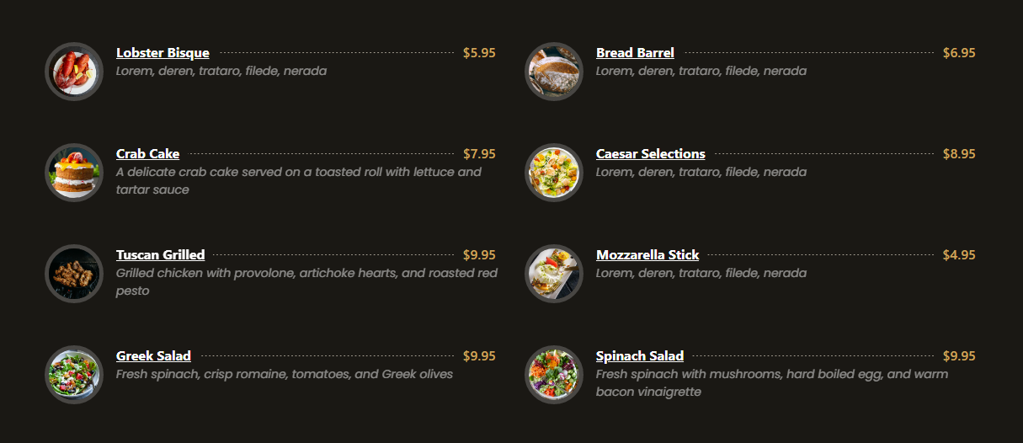

***Figure 6: Description of our Menu bar***

***Use to load the remaining sections. The following is a list of those sections:***

*As we have work on only single page and re-directing on other sections. So, we are made our web directed pages.*

* ***Home Page (1. index (1).html)***
* ***About Page (2. index (1).html- About Section)***
* ***Services Page (3. index (1).html-Services Section)***
* ***Portfolio Page (4. index (1).html-Portfolio Section)***

*Portfolio details(5.Portfolio-detail.html)*

*Portfolio details(6.Portfolio-details-2.html)*

* Portfolio details(7.Portfolio-details-3.html)*

* Portfolio details(8.Portfolio-details-4.html)*

* Portfolio details(9.Portfolio-details-5.html)*

* Portfolio details(10.Octopus-details.html)*

* Portfolio details(11.Jellyfish-details.html)*

* Portfolio details(12.Beluga-details.html)*

* Portfolio details(13.Penguine-details.html)*

* ***Dine Inn Page (14. index (1).html)***
* ***Visit Page (15. index (1).html)***
* ***Contact Page (16. index (1).html***

***7. Video link:***

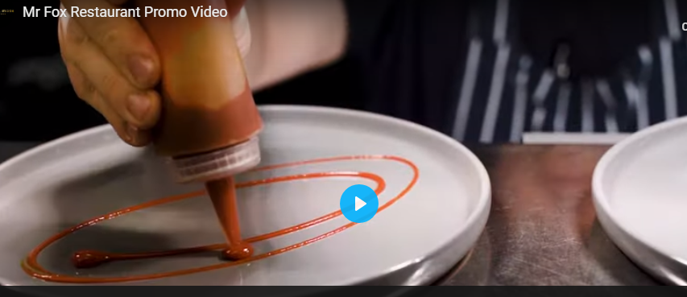

***Figure 7: Linked Video***

***We have put our Aquarium survey video link from YouTube for the attraction of client.***

***10.Dine Inn (index (1).html):***

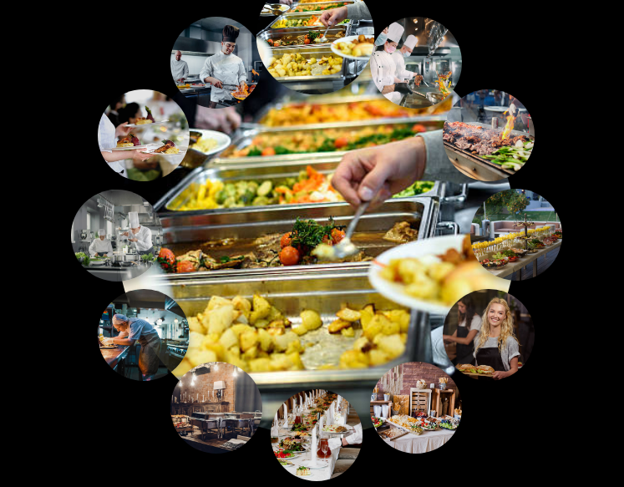

***Figure 10: Dine Inn***

Our dine inn page is designed to elaborate about our aquatic environment and our timings and other policies are also mentioned there.

***13.Contact (index (1).html):***

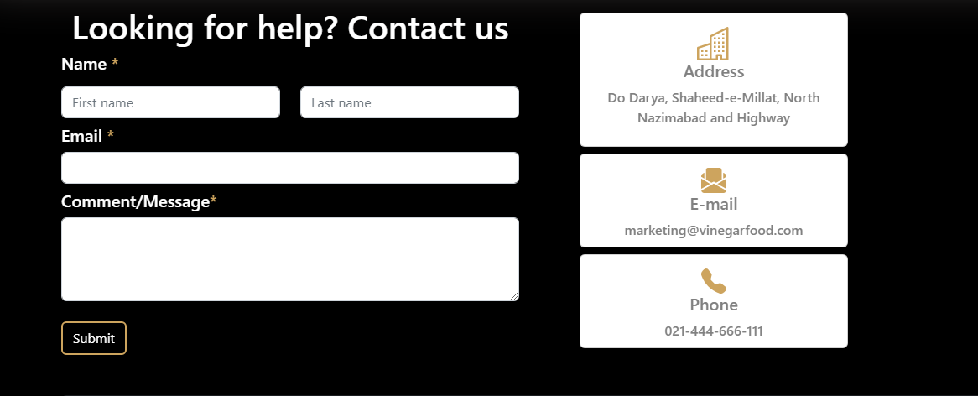

***Figure 13: Contact***

*In our contact section we have given location map for the ease of the people*

*Email id and phone number for contacting in case of any problem.*

*Feedback Form:*

*To know the response of the people our team has given feedback page for the ideas and feedback of the people.*

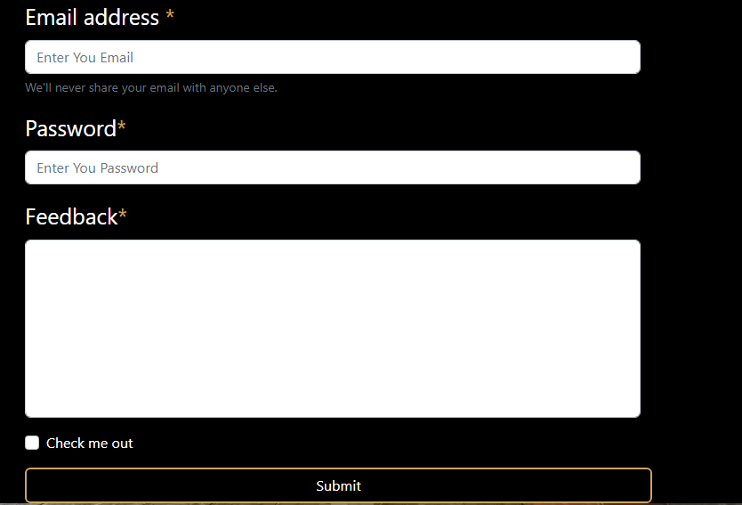

***14Inner Page(inner.html):***

